**Cryptocurrencies – Making Right Investment**

**What is a Cryptocurrency?**

Cryptocurrency is defined as a currency which uses cryptography and is associated with the Internet. It involves a process which converts legible information into a code in such a way that it can be helped in tracking purchases and transfers.

The first cryptocurrency which was officially registered is “Bitcoin”. In common man’s terms, cryptocurrency is a digital currency that is mined instead of being printed.

**How does one acquire a cryptocurrency?**

A cryptocurrency for example Bitcoin is acquired by purchasing the coin via wallet something like a normal purchase that can be through credit card or online transfer.

The wallet helps you to invest in various cryptocurrencies using your flat currency (existing currency).

**How do you mine a currency?**

Mining is a fundamental concept in understanding working protocol of cryptocurrency. It refers to a decentralized process which reviews each block of the block chain to reach consensus without including central authority in picture.   
Mining is equivalent to peer review in environment where parties follow consensus model. Mining with respect to crypto currencies involve two primary roles  
1. Adding new bitcoins to the pool

2. Verifying transactions.

After verifying transactions, the successful block is published in blockchain network and others are maintained in transaction pool. A miner always interacts with the header of block which includes block id and hash values which helps for smooth functioning of mining process.

**Definition: Blockchain**

Blockchain involves two terms namely “Block” and “Chain” where every transaction is considered as a block. These blocks are connected to each other as chains. The connections consist of hashes which includes information of every transaction completed.

The structure of Blockchain includes relational data storage that provides a shared ledger and backbone of the coin.

A picture containing top, small, grass, sky

Description generated with high confidence

As visible in the figure above, blockchain is the linked decentralized series of the blocks.

Cryptocurrency is an example of decentralized application whose data structure is a blockchain.

**How does one invest in Crypto?**

Various factors are involved for investment in Cryptocurrencies.

A simple way of investing in cryptocurrency is buying and holding coins on an exchange. Simple exchange can be considered as risky as these exchanges can be hacked and there are chances of coins being stolen. The other way of investing in Cryptocurrency is storing on a computer wallet or a hardware wallet which reduces the risk of being hacked. It is important to thoroughly research each cryptocurrency to decide on which cryptocurrency to invest. The better idea is to spend some time in trends and understand most prevalent currencies. The popular crypto currencies which are trending in market are mentioned below:

**Bitcoin**

Bitcoin is a well-known crypto currency that was introduced in 2008 and it became so popular that its value grew extremely fast and has reached exponential heights. In market capitalization standards, it is considered as the most valuable coin.

The trend overall is in good shape and attracting the buying interest.

The increasing value of Bitcoin in past years is depicted in following trend chart:

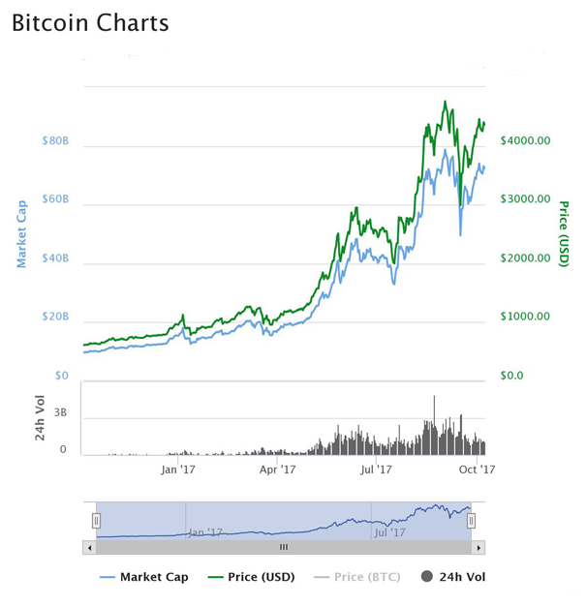

The trend chart between periods of 10 months from January 17 to Oct 17 depicts the increasing value of Bitcoin in market.

**Ethereum**

Ethereum (abbreviated form as ETH) is a well known decentralized software built for developing applications and transactions unlike Bitcoin which is only focusses on transaction models. Ethereum enables smart contracts, the digital agreements which are undertaken to complete a transaction.

It enforces an individual to follow the protocols defined in it under which a person will be paid if the associated terms and conditions are met. The money will be automatically transferred to a person without any intrusion.

Consider for the following trend chart of Ethereum between Jan 1, 2017 to Oct 1, 2017:

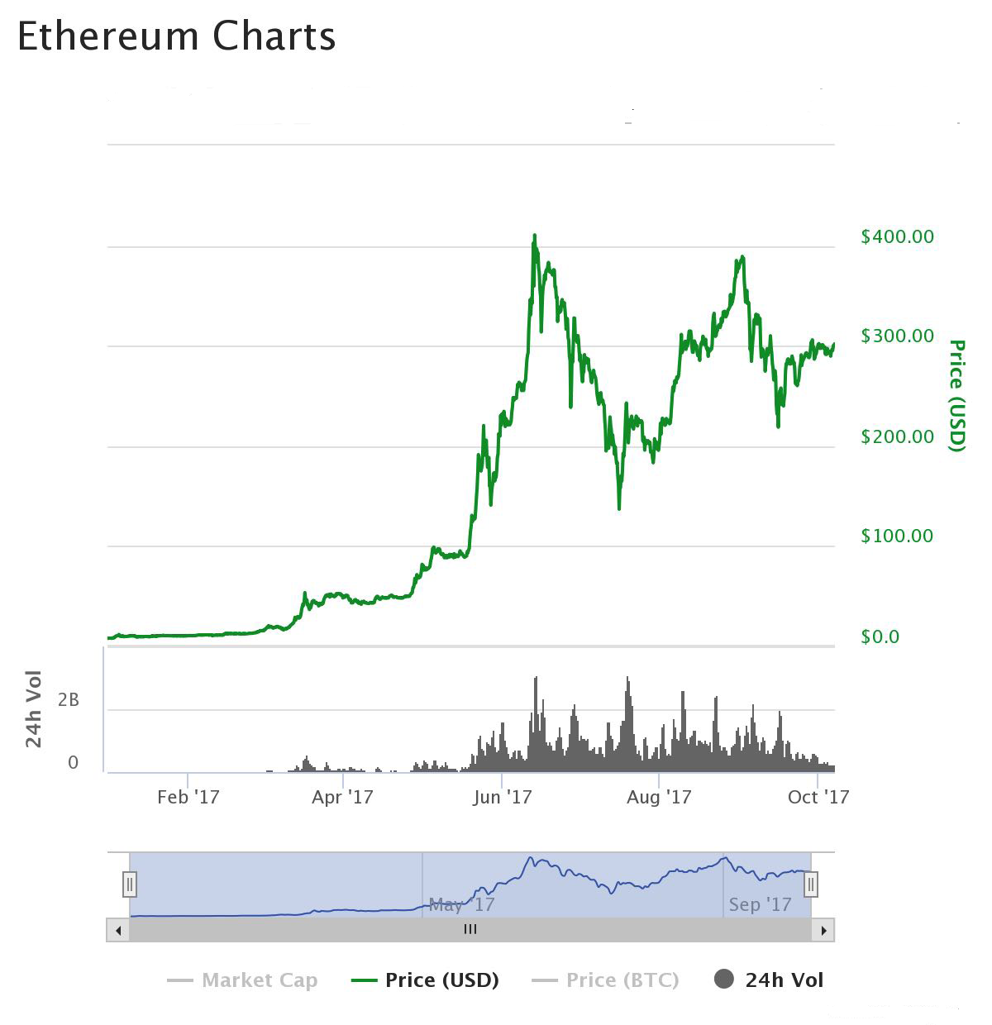

**Litecoin**

Litecoin also called as LTC was launched in the year 2011. It can be considered as an alternative crypto currency based on Bitcoin. It is an open source global payment network which is not under any central authority.

The difference between Litecoin and Bitcoin are basically in regard to faster block generation rate and proof of work scheme.

The trend chart depicting growth of Litecoin:

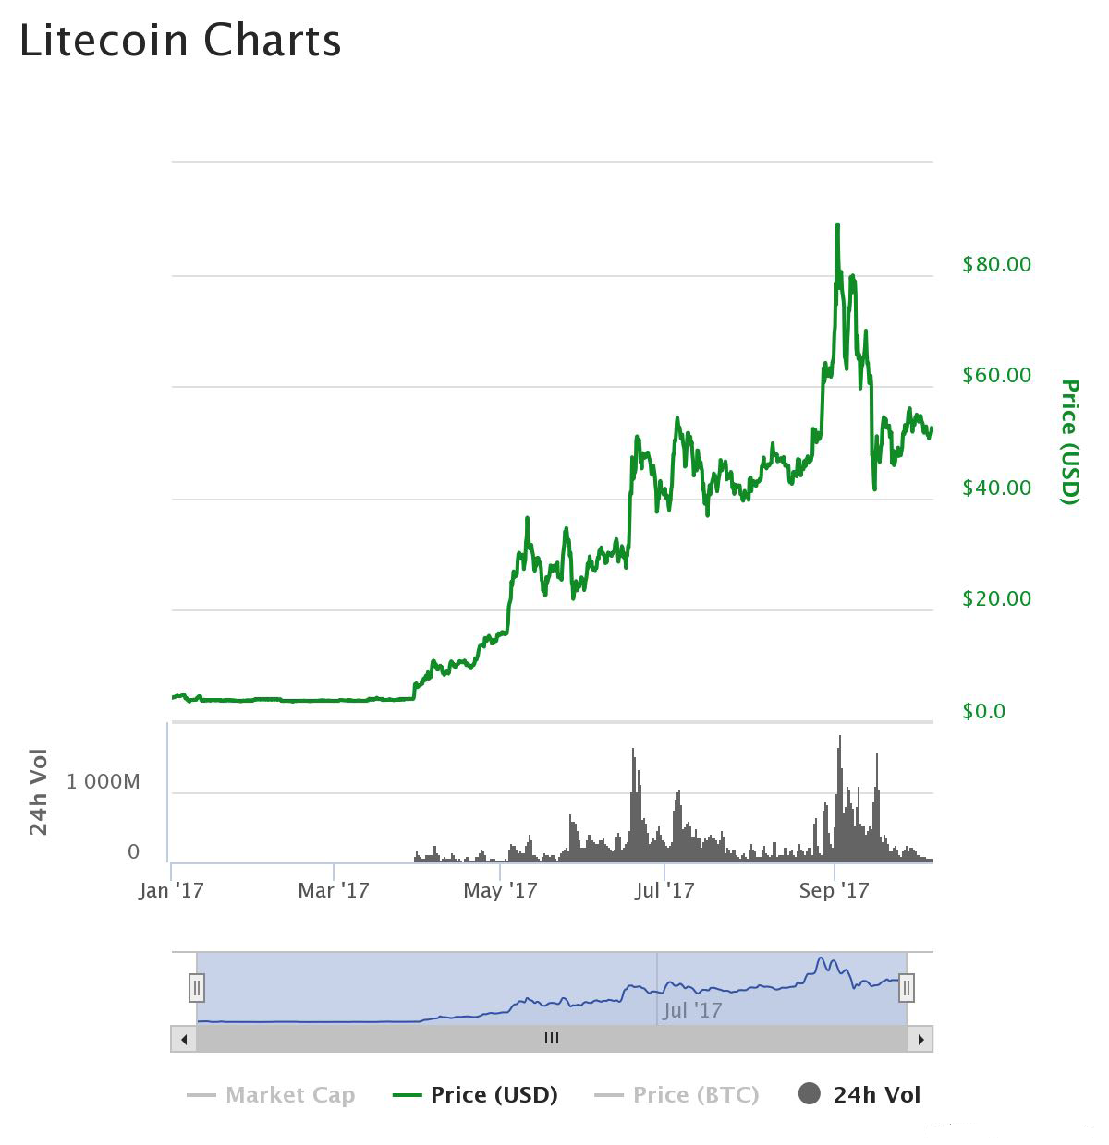

As visible in the trend chart, Litecoin was experiencing new highs which were followed by an exponential growth from value of $4 in the month of April 17 to $90 in Oct 17. The overall trend looks soothing but it is always suggested to buy on weakness.

**Pros and Cons of Cryptocurrency**

**Advantages**

1. Easy and Fast

Making payment is easy without using credit cards or any signatures. The only information needed is the wallet address of a person or organization to which money is to be transferred. The process of the money transfer is speedy and completed in seconds.

2. Secure  
Use of cryptography for encryption of confidential data ensures security. No person except the owner of wallet can receive or transfer the payments or conduct any transactions.

3. Low Fees

Banks usually charge fees for money transfer . These charges can be eliminated with crypto currency.

4. No Fraud  
Chances of intrusion are meagre as the owners of the wallets can conduct the transactions and the transactions cannot be reversed.

**Disadvantages**

1. Immutable

The transactions once completed are irreversible and it can’t be tampered as it follows the block chain data structure. So, if you have transferred money to some other person by mistake it cannot be refunded unless the person transfers the money back.

2. Not widely accepted

Many companies or websites have not accepted crypto currencies. If the user has crypto currency then he/she will have to search for the service provider which accepts crypto currencies or has a wallet in order to conduct a transaction.

3. Risk of Wallet Loss

The digital currencies are usually stored in a system or smartphone and if the wallet is lost due to any reason, then there is no way to get money back. Also, if your account is hacked, then you won’t be able to complain to the Police or any authorities. However, there are still means of keeping it safe by keeping records offline.